


The Monthly Newsletter of the Lansing Junior Chamber of Commerce  December 2004

Lansing Jaycees (517) 853-8620 Region D
PO Box 16150 www.lansingjaycees.org Population Division 7
Lansing, MI 48901 Base Membership: 79

2004 Board of Directors

Welcome to our newest members!!

Mark Quimby, Edward Jones

Lynn Schramm, Michigan Millers Mutual Insurance

President
Sara Ballard (517) 388-1220
Chair of the Board
Amy Miller (517) 699-0048
Treasurer
Angela Backus (517) 980-3759
Secretary
Tierany Myers (517) 230-1677
Legal Counsel
Thomas Barger (517) 272-5144
Membership Development VP
Jimi Carolan (517) 775-2744
Community Development VP
Sheila Wiitala (517) 482-4615
Individual Development VP
Matt Wiitala (517) 482-4615
Management Development VP
John Pulice (517) 351-4315
Community Development Director
Rachel Pavlik (517) 337-2007
Individual Development Director
Sheryl Soczek (517) 664-1650
Public Relations Director
Mike Flaminio (517) 980-6453

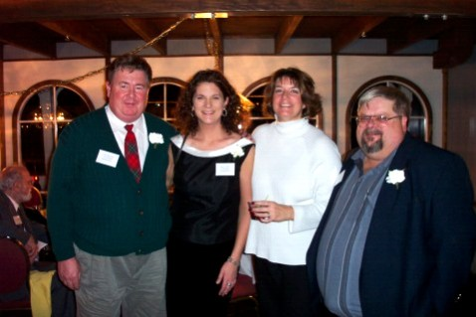

In This Issue

From the President Pg. 2-3
Membership Development Pg. 4
Individual Development Pg. 5
Community Development Pg. 6
Management Development Pg. 7
Calendar of Events Pg. 8
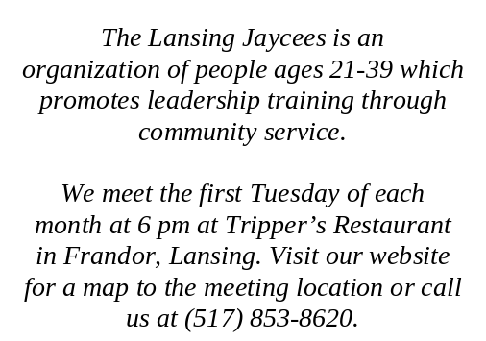

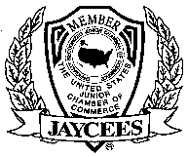

Past presidents Tod Macauley, Amy Miller, Dee Griffiths, and Bob Pancost reminisce at the 75th Anniversary Banquet…See page 7 for more!

2003 Annual Awards and Installation Banquet
From the President…
This year it has been our mission to reconnect with our community – educating them about what the Jaycees do and how we can partner to make changes in the community we live in. In 2004 the Lansing Jaycees have assisted in over 36 community projects and raised over $4,000 for community organizations. But sometimes it takes more than just volunteering for one day or donating money one time; sometimes it take years of desire, dedication, and pride to make significant contributions to your community. That is why I would like to recognize the following individuals for their exemplary work in their own community. We are proud to have them as members in the Lansing Jaycees and thankful for the leadership and resources they bring our chapter. Kathy Dunbar, for not only recognizing change in her neighborhood and schools but doing something about it by and building what is known today as the Southside Neighborhood Association; Rina Risper, the Editor-in-Chief and Owner of the New Citizen's Press for creating a forum where poets can express themselves and we can enjoy their poetry; Jamie Prevo for her determination for improving her own neighborhood and spearheading the Business portion of the Saginaw/Oakland Revitalization Project; and Angela Mills for recognizing the need for volunteers at Old Town Festivals and creating and building a list serve to recruit those volunteers from.
I would like to thank the following Lansing community groups for their assistance in attaining our goals this year. The following groups provided substantial assistance in many of our projects and endeavors this year.

Southside Neighborhood Association | Old Town Association
Volunteers of America | Lansing Public Facilities Authority
Creation Station | Potter Park Zoo
Impression Five Science Center | Comcast-Public Access TV
The Lansing Lion's Club | Lansing Police Department
The South Lansing Kiwanis Club | Highfields
Ingham County Parks | City of Lansing-City Council and Mayor’s Office
Northside Healthy Neighborhood Initiative | Lansing Neighborhood Council
Polish Federated Hall | Lansing Area Chamber of Commerce
Child and Family Services | Lansing Area Hispanic Business Association
The Capitol Area Library | Student Consultants of MSU
Ingham County Care Facility | Volunteer Center of Mid-Michigan

Sara Ballard
76th President
Lansing Jaycees
“Where the human mind and soul come to play”

Jaycee Creed
by C. William Brownfield

We believe that faith in God gives meaning
and purpose to human life;

That the brotherhood of man transcends
the sovereignty of nations;

That economic justice can best be won
by free men through free enterprise;
That government should be of laws
rather than of men;

That earth’s great treasure
lies in human personality; and that
Service to humanity is
the best work of life
From The President (cont.)

December GMM
Tuesday, December 7th
Dinner at 6:30 PM
Meeting at 7:00 PM
Tripper’s in Frandor (see map below)

PASS ‘DA TRASH, SANTA'S WORKSHOP, & A MEETING – All in one night!
First we will have 'DA MEETING' which will be short and sweet, covering the events that are happening for the rest of December and some of the new events happening in January.
Then its ‘PASS DA TRASH’, where your worst birthday gifts and wedding presents become someone else’s. Yes, every year the Jaycees do a white elephant gift exchange, where you bring a present and by the luck of a lottery you could acquire someone else’s trash. Extra gifts will be provided for those who forget, run out of time, or don't have a closet.
After Pass the Trash we'll be turning Tripper’s into Santa's Workshop as we wrap presents for the family the Jaycees adopted. I bet ya’ there would be a higher retention rate for elves if Santa's Workshop actually was in a sports bar!
P.S. We will be accepting monetary donations for the Adopt-a-Family that night to provide gift certificates to the family for a nice Christmas Dinner.

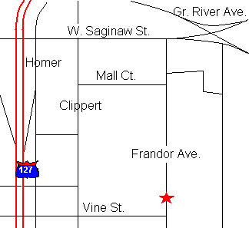

NOTICE OF BOARD MEETING
DATE CHANGE
Because of the holiday schedule the board will meet on Sunday, December 12th at 3:00 PM at the Service Center.

Service Center Clean-Up
December 4th
10 AM = 2 PM

Time to clean up our Service Center! Throughout the year the Lansing Jaycees utilize storage space and meeting space at the MIJC Service Center. Throughout the year, this building has had some wear and tear and needs our tender loving care. We also need help organizing and filing chapter paperwork for the year. We need your help. Please help the building we use look beautiful by attending the Service Center Clean Up Day on December 4th from 10AM - 2PM.



Hellooo Jaycees! This will be my last article as your 2004 Membership Development VP, but I will be stepping into the 2005 District Director position. So, please let me know if you have any questions, comments, suggestions, etc. It has been a great year, and I’m sure the year coming up will be wonderful also!

Welcome, welcome! Our newest members in November are Lynn Schramm & Mark Quimby.

In November, the Lansing Area Young Professionals Mixer was quite successful. There were 19 people in attendance. I think members and prospective members had a great time. Anyone that brought a guest went into a drawing for $20 off his or her membership dues. Congratulations Theresa Dodd!

At the November GMM, another drawing was held for the Be There To Win Prizes. Prizes included passes to NCG Cinema (donated by The New Citizens Press, Rina Risper) and pre-paid phone cards (donated by Jimi Carolan). Patrick Talty’s name was drawn, but he was not present. A second drawing was held, since the passes expired in November. Teri Bruning won! The phone cards will be in the drawing at our December GMM on the 7th along with…? ☺

Ahh, December…On the 1st, International Beer Night will be taking place at Reno’s East. Please contact Patrick Brazil, pjbrazil@ft.newyorklife.com, or Aron Clark, aclark@providencelending.com, for all the information. The cost is $10 for 8 different beers & appetizers. It was a lot of fun last time, and I’m sure it will be this time!

Please plan to help clean up the Michigan Jaycees Service Center on December 4th. We will be there from 10 AM until 2 PM. Any help you could provide will be greatly appreciated. The Service Center needs our help! Our chapter uses the service center on a regular basis, so please help fix/clean it up.

On the 14th, the Lansing Regional Chamber of Commerce will be having their final mixer of the year at 2 Feather Road House & Patio in Holt. The mixer is from 5 to 7 PM, and costs $10 & a business card. The cost includes beverages and hors d’oeuvres. Some of us have attended the mixers in the past, and plan to attend this one.

New member orientation is scheduled for December 15th at 7 PM. It will be held at the Michigan Jaycees Service Center, upstairs. If you are a new member, thinking about becoming a member, or never attended new member orientation, please plan to attend. This session will provide information about the Jaycees at the local, regional, state, national, and international level.

Jaycees, thank you for this year! I have learned a lot through the year, and plan to use this knowledge in the future, as your 2005 District Director. Congratulations to Chris Vieth, 2005 Membership Development VP, and Kim Doughty, 2005 Membership Development Director!

Address, phone number, or email changed? Keep it up to date on the Jaycees website, www.lansingjaycees.org.

Pay dues the easy way…PayPal through the Jaycees website.

Jimi Carolan,
2004 Membership Development VP

Membership Development

Individual Development
Individual Development’s schedule has been very light of late but we will be ramping things up as we move into 2005! We are looking at going to the musical “Movin’Out,” based on songs by Billy Joel, at the Wharton Center, February 1st-6th. More information on this event will be coming out shortly as tickets do go on sale December 13th.

Very shortly, the Member’s Survey will be going out and Individual Development will be soliciting your thoughts and ideas for what you thought we did successfully in 2004, what can be done better, and programming and events you would like to see in 2005.

Some highlights from 2004 include: The Annual Ski Trip; Scuba Diving Splash Party at Haslett High School; Maple Syrup Festival (so, okay, maybe it didn’t end up there – you had to be there); Wine Weekend to Traverse City; Pottery Night; Memorial Day Weekend Whitewater Rafting Trip to West Virginia; CPR Certification; Camping Cooking Class; Annual Camping Trip; Who Wants to Be a Millionaire; Dale Carnegie Workshop; Diversity Presentation; and the 2nd Annual Detroit Tigers Trip. The wonderful thing about these events is Individual Development was able to reach so many different members of our Chapter and we look forward to doing it again in 2005.

We would like to emphasize that Individual Development programming is designed to enhance our members’ (i.e. YOUR) professional and personal development. If you have any ideas for upcoming programming or events for 2005, make sure to fill out your Member Survey or contact Matt Wiitala at 482-4615 or mtwiitala@hotmail.com or Sheryl Soczek at 664-1650 or ssoczek@mail.grandhotel.net.

2004 was a great year for Individual Development. Let’s all do our part to make 2005 even better!

Sheryl Soczek, Individual Development Director

Matt Wiitala, Individual Development Vice President

Old Town Poetry Series

Hi “Nu” Poetry Movement supporters. I would like to invite you out to enjoy poetry with The Old Town Poetry Series group. Since I have been going to their poetry readings I have learned a lot about poetry, listening to and
learning from published poets and I really have to credit them for encouraging us. We should support them too!!!!! Besides, they are a wonderful group of people.
Here is the information:
The Old Town Poetry Series Creole Gallery
1218 Turner Street
In Lansing’s historic Old Town
All events begin at 7:30 PM
Wed. Jan. 12th – Walt Whitman Night
Bring your favorite WW poem or Whitman-like poem.
Sat. Feb. 5th – Spoken Word Workshop at the Mid-Winter Singing Festival
Time TBA
Wed. Feb. 9th – In Honor of Black History Month: Poets & Storytellers
Wed. March 9th – In Praise of the Feminine
Wed. April 13th – The Old Town Poetry Auction

Wed. May 11th – Poets of the Future
Suggested donation is $3 (with a sliding scale from $1-$5), unless otherwise specified. Refreshments are free. Parking is available on the street and in the large parking lot on the south side of the intersection of Turner St. and Grand River Ave.
SAVE THIS SCHEDULE – POST ON YOUR REFRIGERATOR!
Ruelaine Stokes
(517) 267-0410


Happy Birthday!

Tim Recker

Amber Lambert

Susan Rundhaug

Jamie Prevo
Community Development
Thank you to all that helped to feed the homeless on November 14th. Together with the cooks from The Volunteers of America we fed almost 100 people a hearty meal! We helped the cooks prepare chicken, stuffing and green beans. We also helped to get other meals started by peeling and cutting potatoes. In addition to the prep work we helped to set up, serve the food and clean up after the meal. Even though it was a lot of hard work, we had a great time. We’ve also been asked to come back to help out any time. So, look out for another future event!

Thank You -
Kathy Brock
Event Chairperson

St. Johns Brown Bag Auction
December 10th, 7:00 PM
To RSVP, call Sara at 388-1220

It's that time a year again to relax, kick back and bid on some wild and fun gifts! ‘Tis the season for the St. Johns Jaycees Brown Bag Auction and Pot Luck Dinner.

RSVP with the Dish you will bring to pass. We will provide soda and place settings.

Bring as many nice and/or gag gifts in a brown or decorated package as you would like. Don't forget your money to bid! This is a great way to get your Christmas shopping wrapped up.

This year, our earnings will go to our High School Scholarship Program. Each year we give a deserving High School Senior a grant for $500, help us raise our goal! This event is BYOB and for adults only.

Twenty-Second Annual Hispanic Christmas Symposium

The Capital Area Hispanic Community Representatives (CAHCR)
Cordially Invite You to
A Christmas Symposium
Thursday, December 9 , 2004, 6:00 to 9:00 PM
At the Clarion Hotel
3600 Dunckel Rd.
Lansing, MI
Phone: (517) 351-7600

The annual Christmas Symposium provides an opportunity for individuals from different cultural backgrounds to interact in an informal setting and to share in the spirit of the season.
Food, beverages, and music provided.
Donations are appreciated in advance, or
at the door. For more information call:

John Castillo, President, Lansing Area Hispanic Business Association –
(517) 381-8804
Manuel Delgado, Chairman, CAHCR –
(517) 646-6456

District, Region and State News

- The Local Officers Training School (LOTS) will be held Saturday January 8, 2005. Cost is $20 and the deadline for early registration is Monday, December 27th.

- The Michigan Jaycees Year-End Assembly will be held February 11-13, 2005 in Kalamazoo (for more info, visit www.kalamazoojaycees.org/convention/).

Visit http://www.michiganjaycees.org for more information about these and other upcoming events.

Management Development

75th Anniversary Banquet

We celebrated our 75th Anniversary on November 13th, 2004 aboard the Michigan Princess. Sheri Jones was our emcee and the program included speeches by the current Michigan Jaycee President, Tim Royle, 42nd Lansing Jaycee President, Duncan Black, and former Lansing Jaycee Auxiliary and Michigan Jaycee Auxiliary President, June (Mason) Kenfield. 75 people enjoyed the evening with a dinner and a cruise aboard the Grand River. Guests received a commemorative 75th Anniversary champagne flute and a special program. Thanks to everyone who helped make this event possible!

Amy Miller
2004 Chairman of the Board
75th Anniversary Banquet Co-Chair

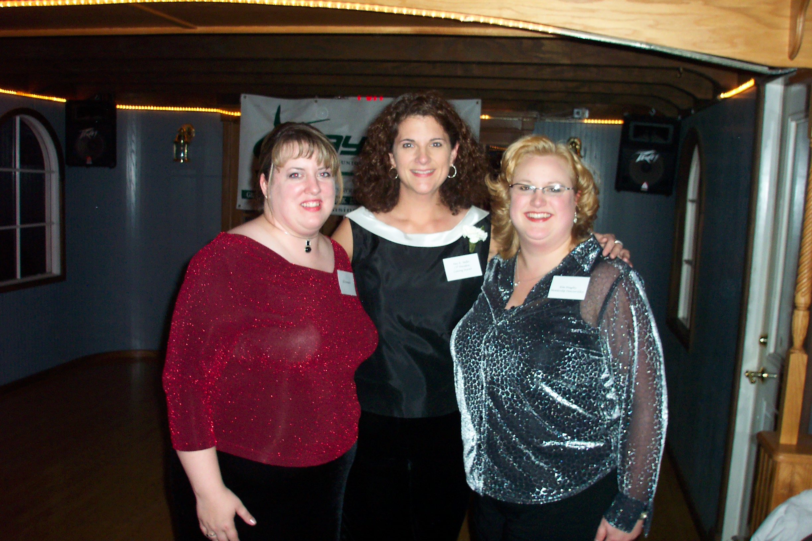

Jill Schumacher, Amy Miller, & Kim Doughty

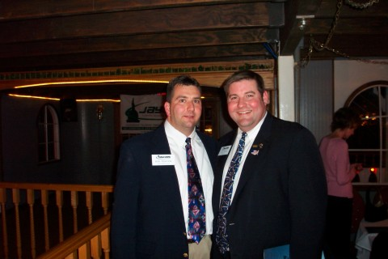

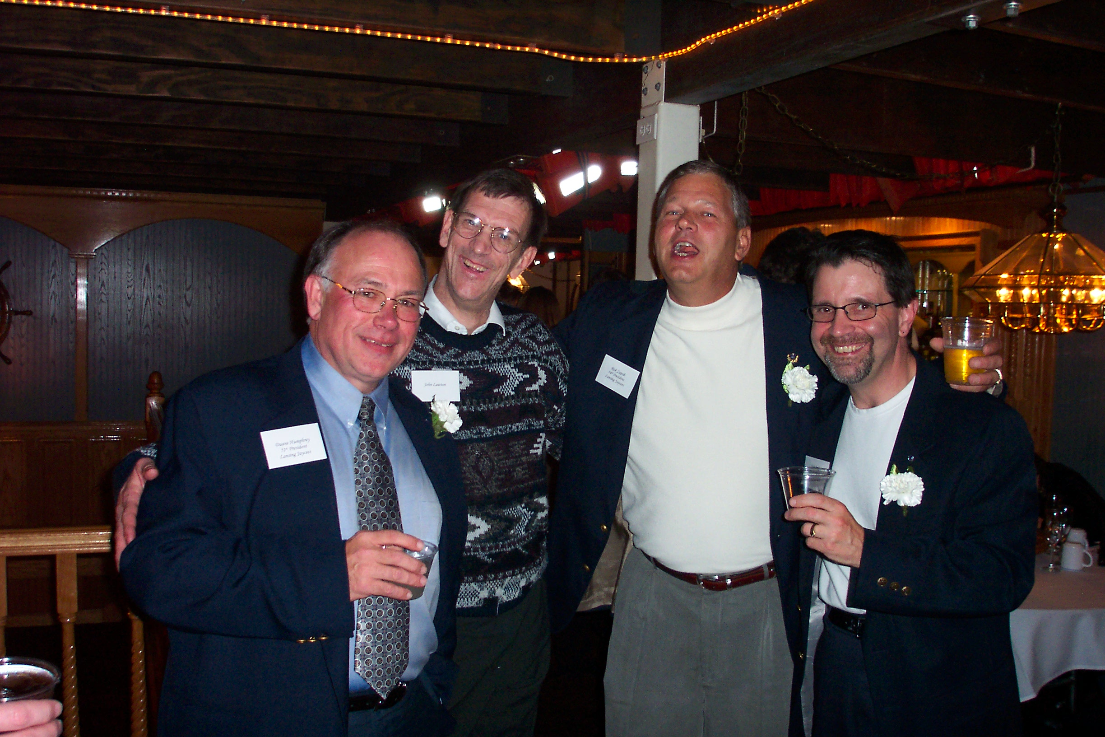
Duane Humphrey, John Lawton, Rick Zapoli,
& Scott Pohl

Bob Peacock and Tim Royle

It has been a pleasure keeping the Lansing Jaycees informed as the 2004 Capitol Correspondent Editor! Watch your e-mail inbox for information about the 2005 Editor and article due-dates so that you can keep “letting your voice be heard”!

Jamie Wilmoth
2004 Capitol Correspondent Editor

Let Your Voice Be Heard!!

Check out the file archives in the Member area of the Lansing Jaycees website for information on the management of the chapter. You can view the Chapter Plan, Board of Directors meeting minutes and financial information. Monthly year-to-date financial statements are available in the file archives or can be requested by emailing treasurer@lansingjaycees.org.
Stay Informed About Your Chapter

75th Anniversary Champagne Flutes Still Available

We have a limited quantity of champagne flutes left over from our banquet. They are available for $5 a piece and will be available at the December 7th GMM. If you are interested, please contact Amy Miller at aemill@comcast.net or (517) 525-0129.
Service Center Clean-Up Day
 |  |   December | 1  Inter-national Beer Night | 2 | 3 | 4
5 | 6 | 7  GMM  7 PM  Tripper’s | 8 | 9 | 10  St. Johns Brown Bog Auction | 11
12  -Region D Training  -December Board Meeting | 13  Child & Family Services Christmas Party | 14  Lansing Regional Chamber Mixer | 15  New Member Orientation | 16 | 17 | 18
19 | 20 | 21  Impression Five Winter Party | 22 | 23 | 24   | 25  Christmas Day
26 | 27 | 28 | 29 | 30 | 31   | 1  New Year’s Day  January
2 | 3 | 4 | 5 | 6 | 7 | 8  Local Officers Training School
9   | 10 | 11 | 12  Walt Whitman  ”Nu” Poets Night | 13 | 14 | 15
16 | 17 | 18 | 19 | 20 | 21   | 22
23 | 24 | 25 | 26 | 27 | 28 | 29
30 | 31

Lansing Jaycees Calendar ~ December 2004/January 2005

December 4th
10 AM – 2 PM
This is our chance to do our part to keep the MI Service Center looking sparkly!
Contact: Jim Carolan
(517) 775-2744

General Membership Meeting
December 7th
Dinner at 6:30 PM
Meeting at 7:00 PM
Come “pass ‘da trash” and wrap real presents for the family the Jaycees adopted!
Contact: Sara Ballard (517) 388-1220

Lansing Regional Chamber Mixer
December 14th
5 PM – 7 PM
2 Feather Roadhouse & Patio in Holt
Chamber mixers are a fun way to meet other interesting professionals in the Lansing area, so don’t miss it!
Contact: Jimi Carolan
(517) 775-2744

New Member Orientation
November 15th
7 PM
MI Jaycees Service Center
If you are interested in the Jaycees, or are a member who would like to talk to other Jacyees about what we do, then plan to attend this informative, fun event!
Contact: Jimi Carolan
(517) 775-2744

Z101.7's
Desperate and Dateless!

Don't let the name scare you.
Are you looking for a mate? Do you need some help?
Z101.7's Morning team Jason and Melissa are looking for you!
If you’re looking for some fun, Jason and Melissa will send you out on a date.
(and pay for it too!)
We need both men and women of all ages to sign up. Send us an email at Z1017Mornings@aol.com.
Just tell us your name, age, occupation and a 2-line description of you and what you’re looking for in a date. Also include your phone number so we can contact you.

If you’re selected, you’ll be on the Z Morning Show on Z101.7’s Desperate and Dateless. It’s a “dating game” style show where you’ll either be one of three bachelor/bachelorettes or the lucky contestant. Either way it will be tons of FUN!

